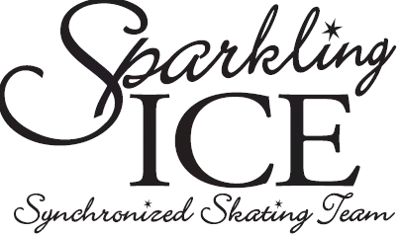

NAME OF SKATER: __________________________________________________

ADDRESS: ___________________________________________________________

CITY: _________________________________POSTAL CODE: _______________

PHONE NUMBER: ___________________________________________________

PARENT’S NAMES: _______________________/___________________________

CELL NUMBERS: _________________________/___________________________

EMAIL ADDRESS: ___________________________________________________

DATE OF BIRTH: ____________________ AGE AS OF JULY 1ST, 2013: ______

SKATE CANADA NUMBER: __________________________________________

SKATING CLUB: ____________________________________________________

HIGHEST SKATING LEVEL ACHEIVED
CANSKATE BADGE: _____________________________
DANCE: _____________________________
SKILLS: _____________________________
FREESKATE: _____________________________

HAVE YOU SKATED SYNCHRO BEFORE? WHAT TEAM? ________________________________________________________________________

I give my child permission to tryout for the Sparkling Ice Synchro Team and I understand that, the above skates at his/her own risk and that there is no liability on the part of USC or its directors. This tryout is sanctioned by USC.

Date: _________________ Parent’s Signature: _______________________________

FOR OFFICE USE ONLY
PAID BY CHEQUE ~ #______$______ PAID CASH ~ $________

RECEIVED BY:_____________

